727721euit169 – Tarun MB

Cloud Computing:

Coding Contest-1

Q1. Create the EC2 instance:

1. Give a name tag for both ec2 instance and key pair as “ec2usecase1” :

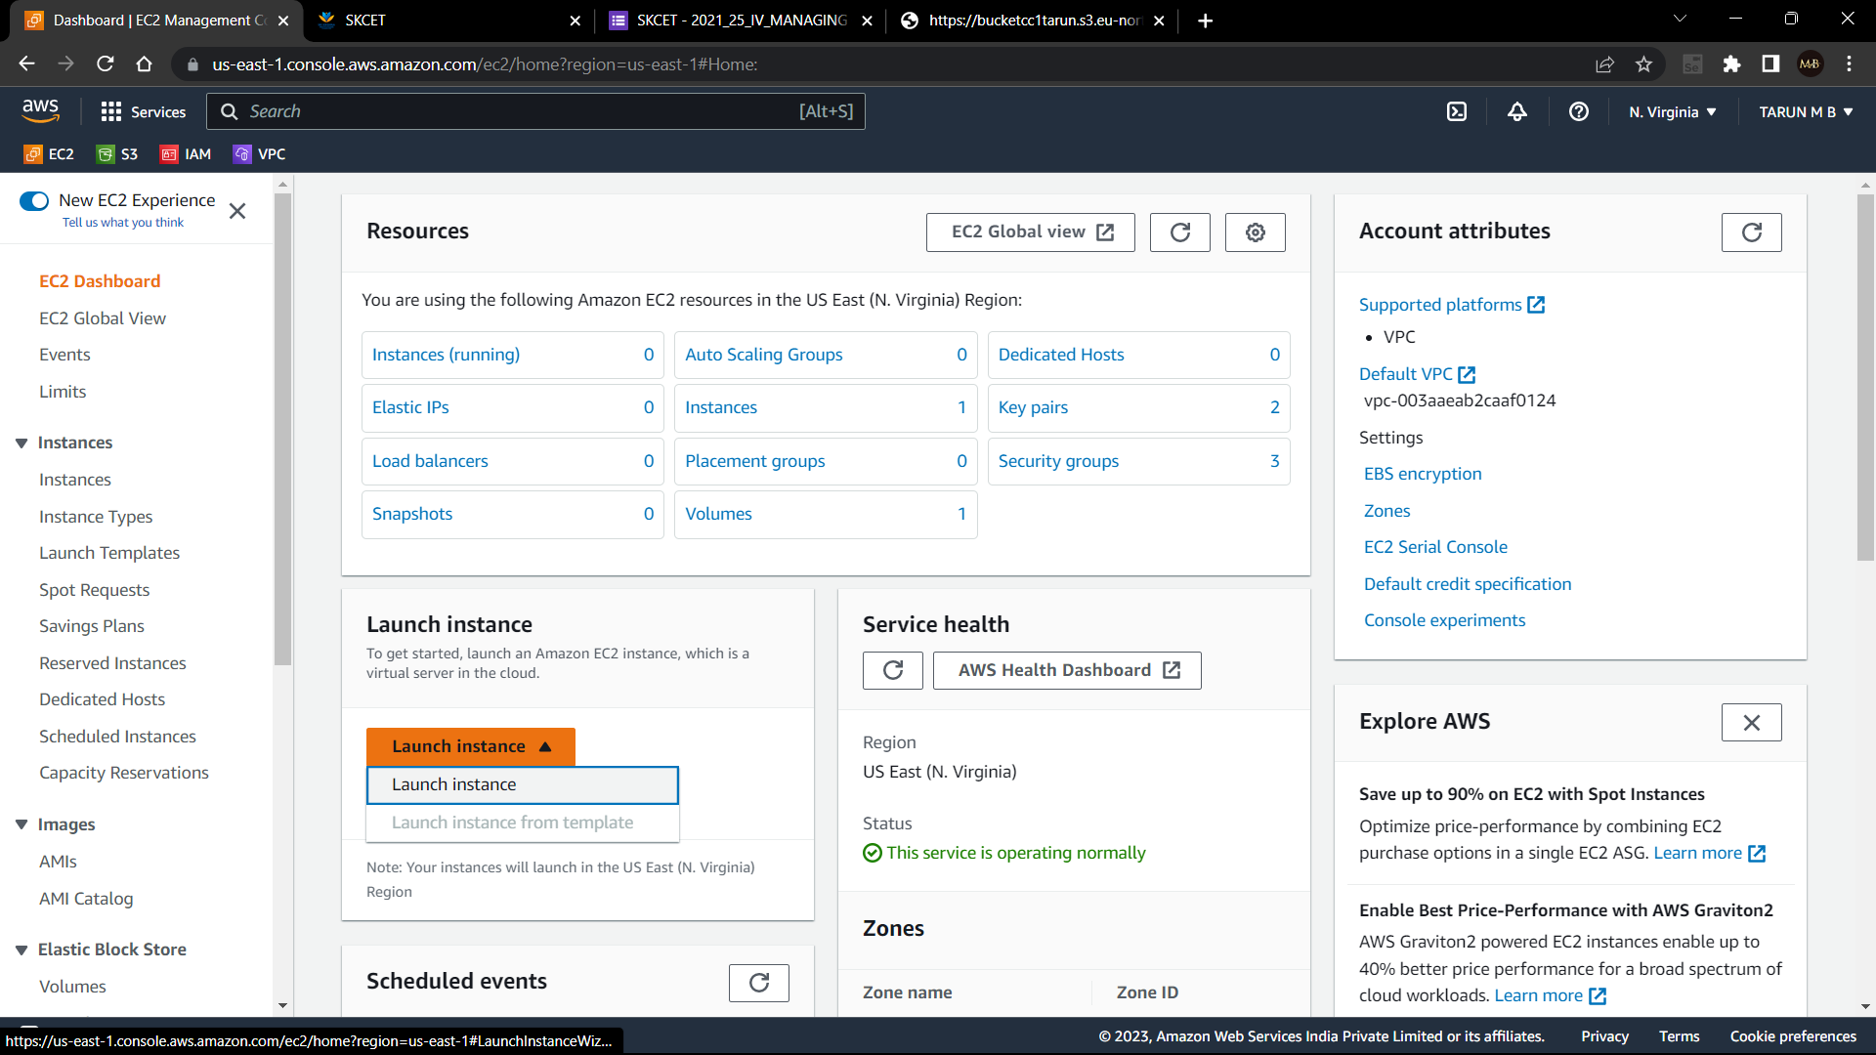

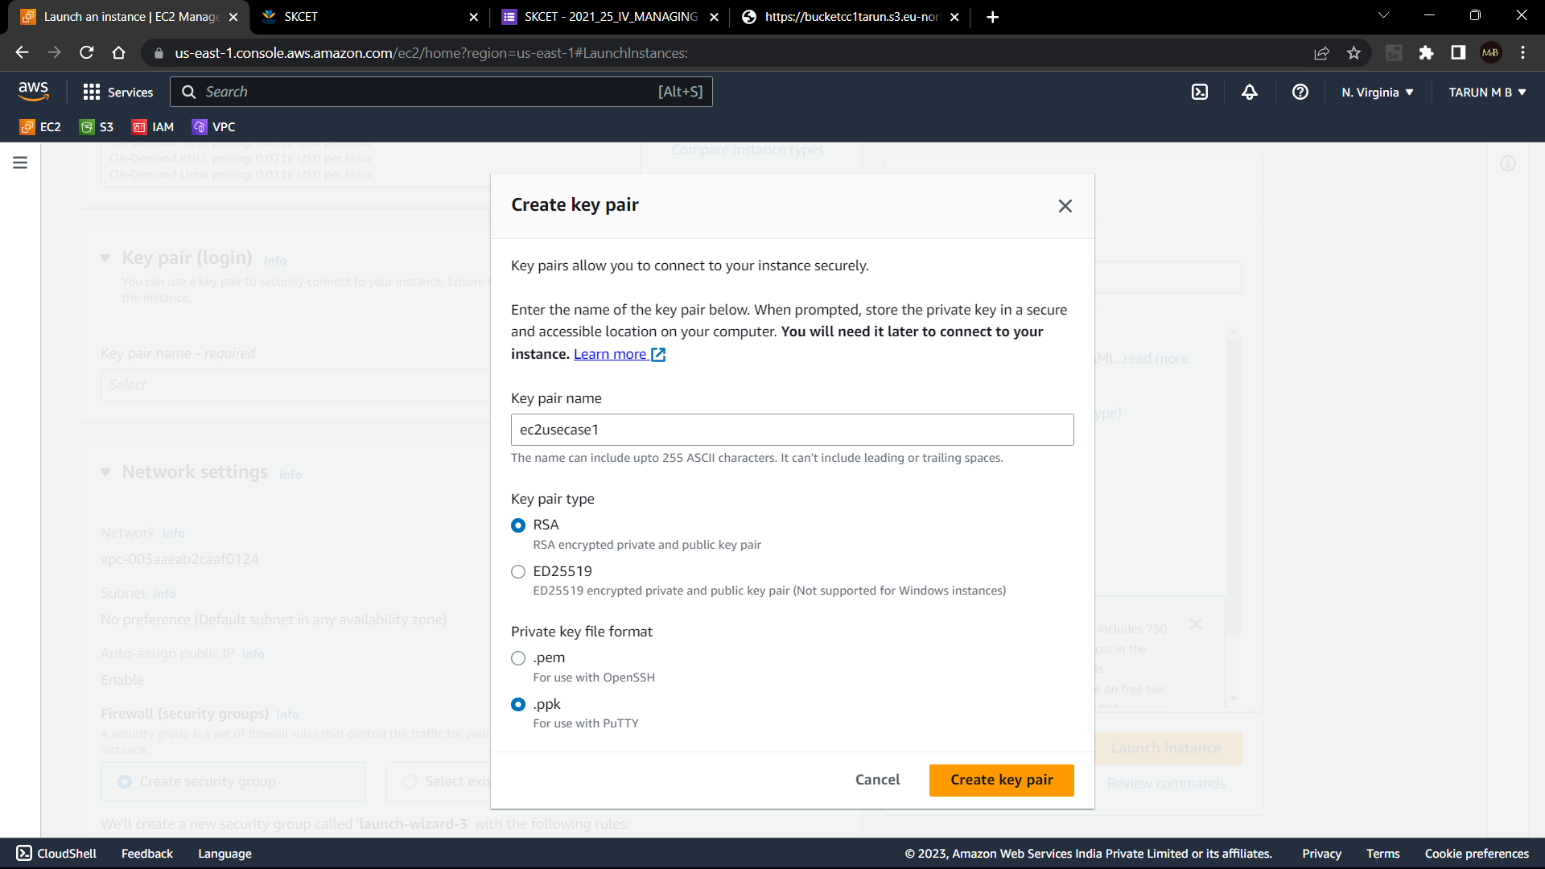

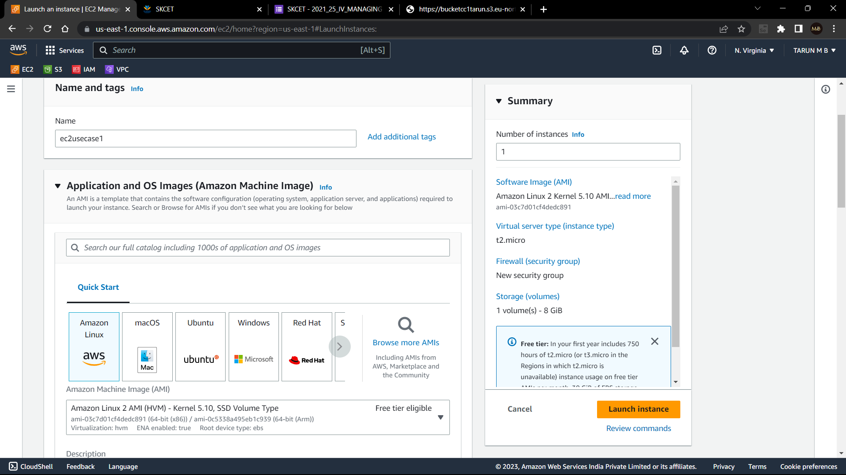

1. EC2 instance should be “ Amazon Linux 2”:

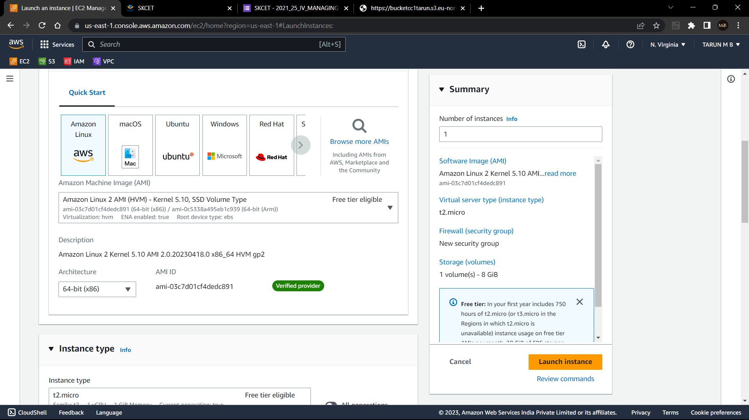

1. Allow ssh traffic for putty remote connection:
2. Allow http traffic from the internet for reaching web site request:

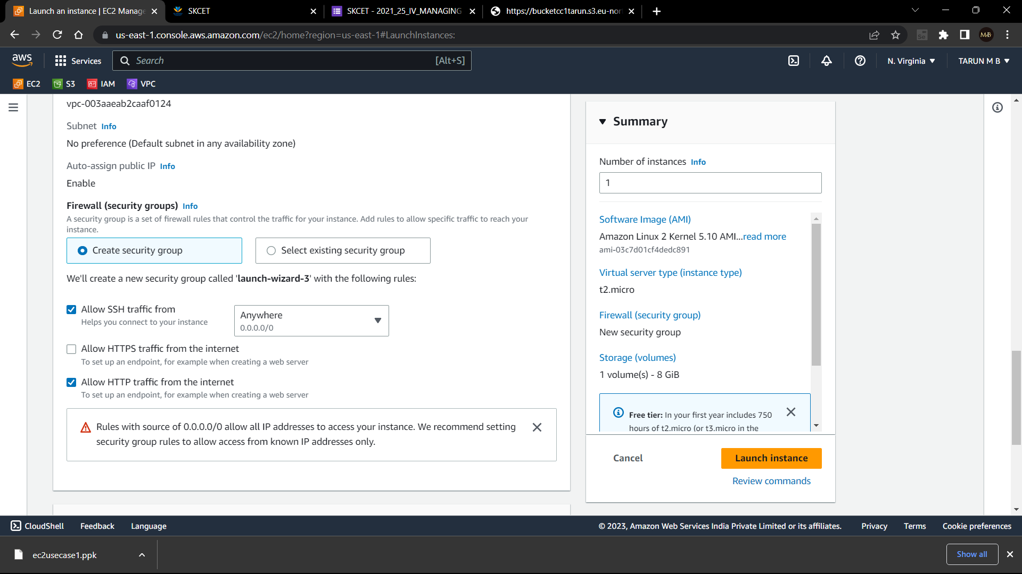

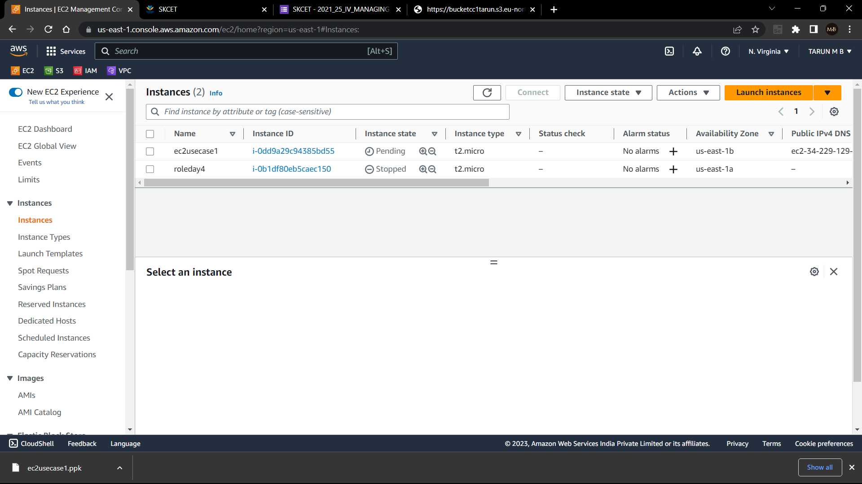

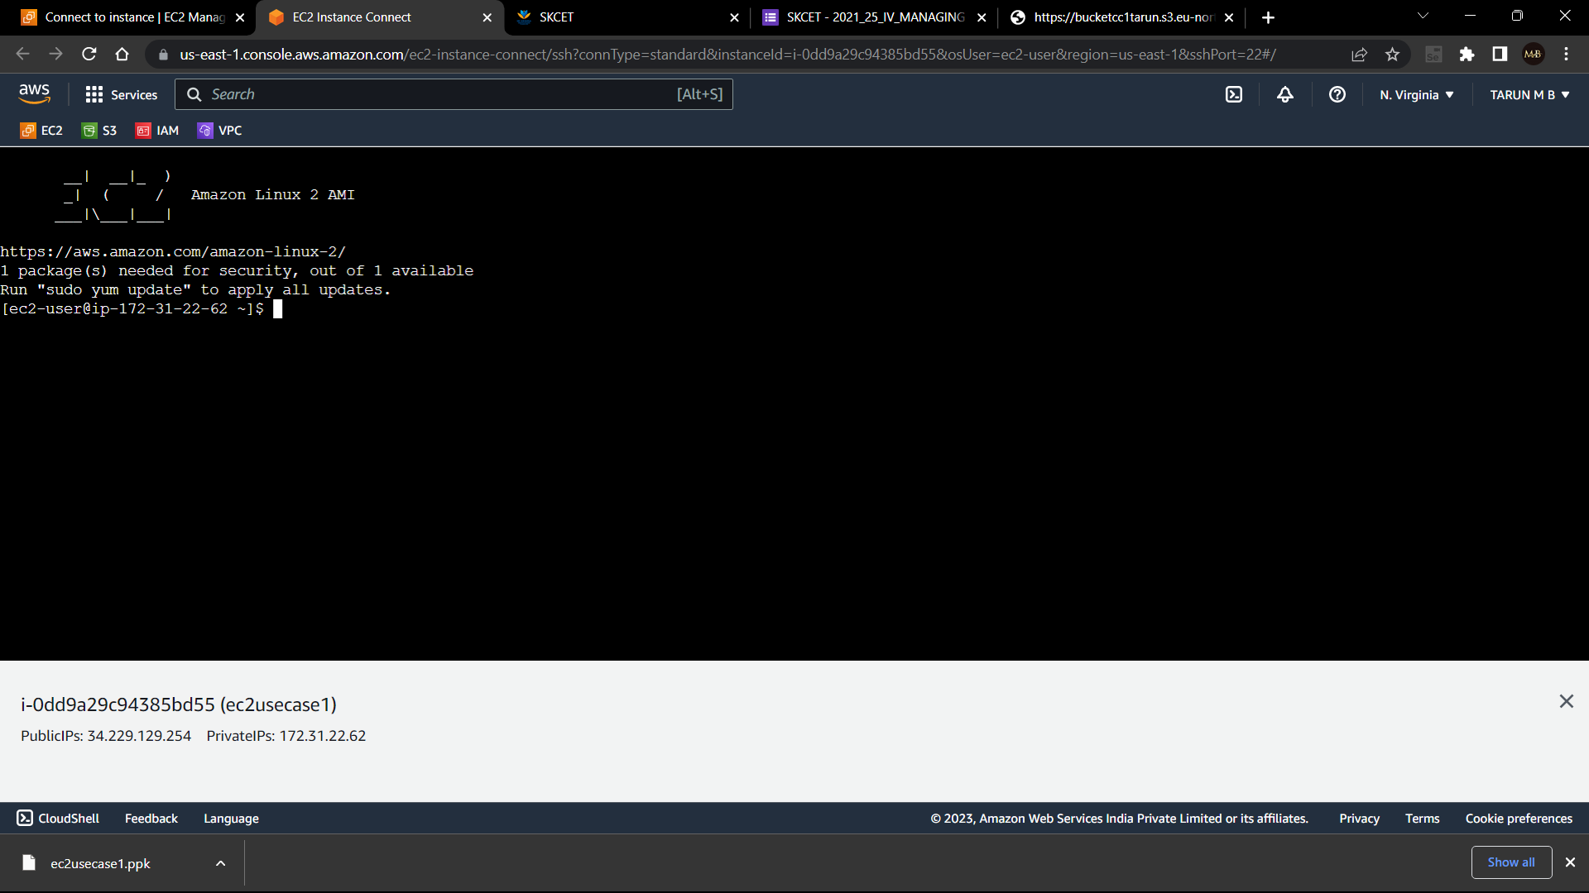

Q2. Create the IAM group:

1. Name of the IAM group should be “ Network-L1-Team”

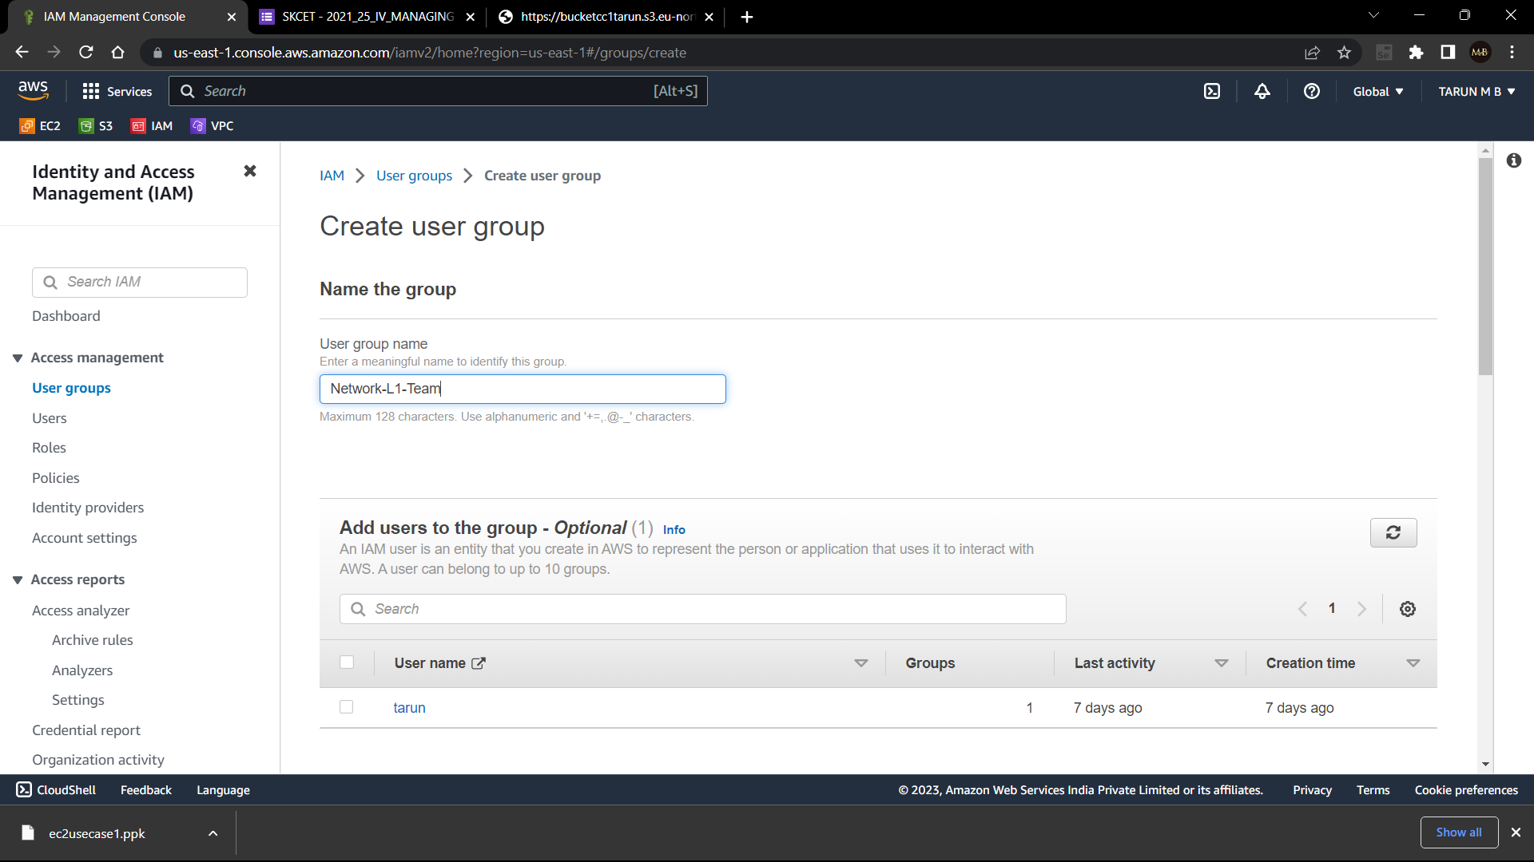

1. Name of the IAM user should be “ Network-L1-User1”

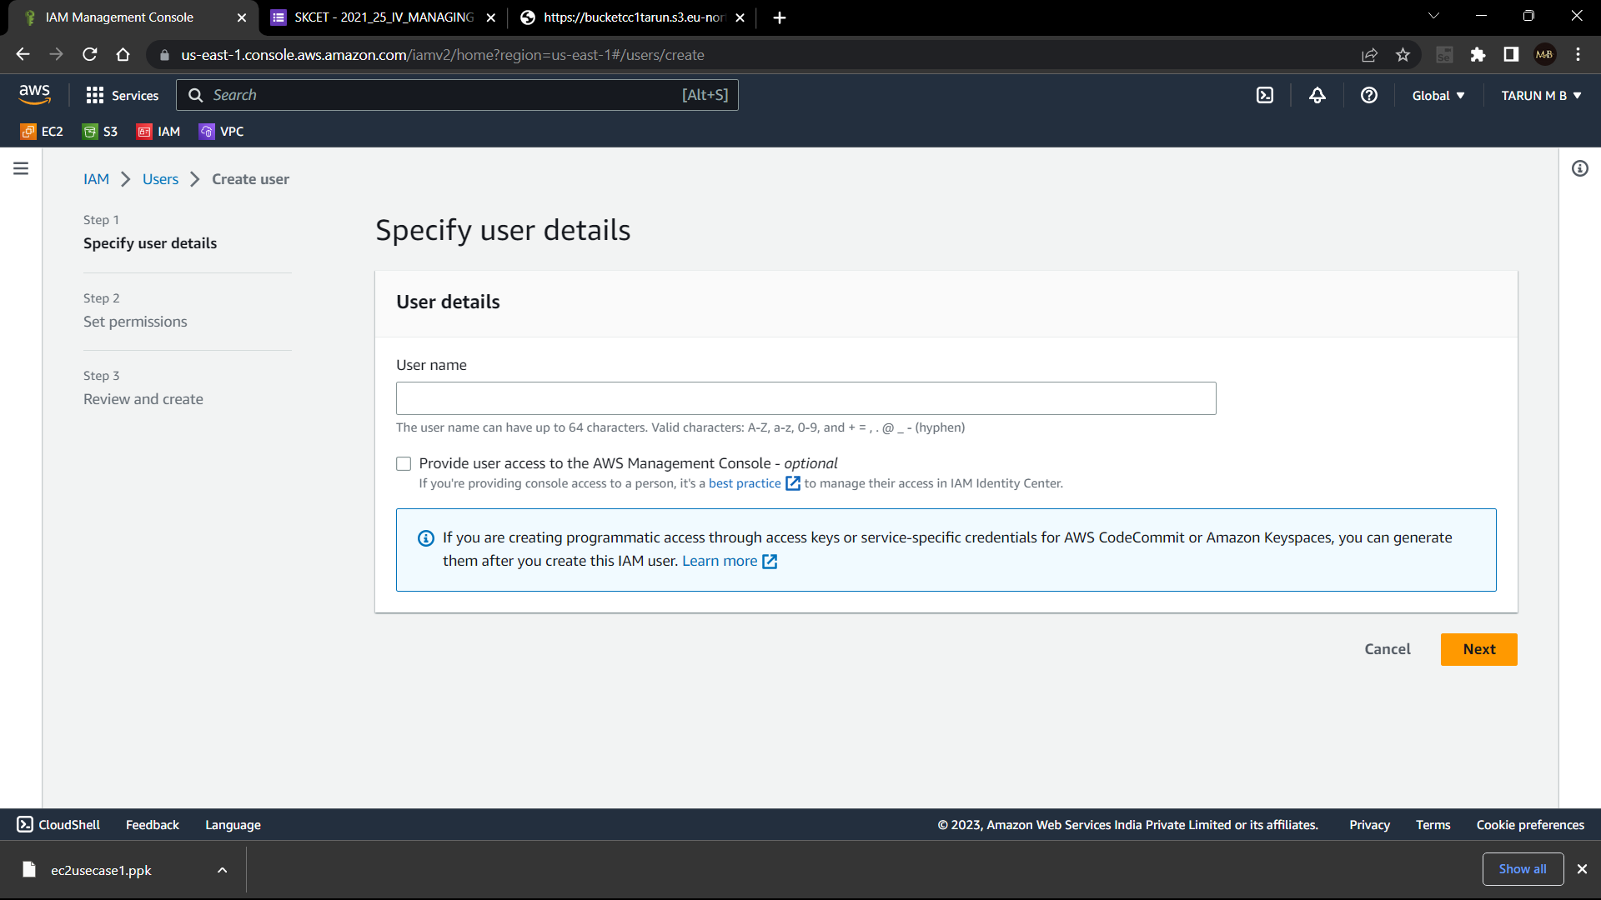

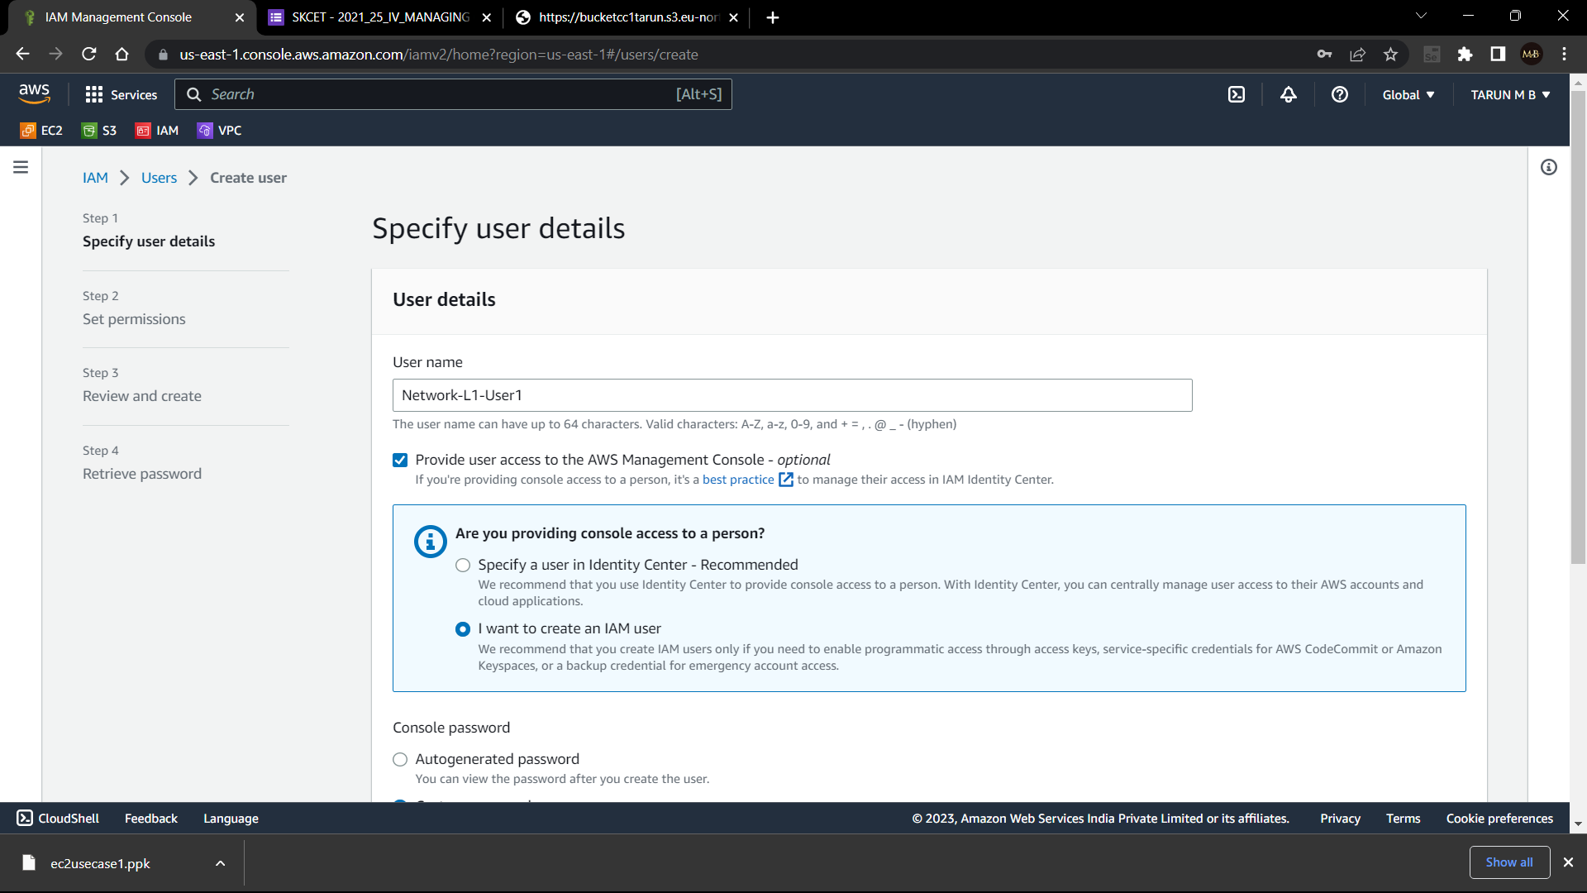

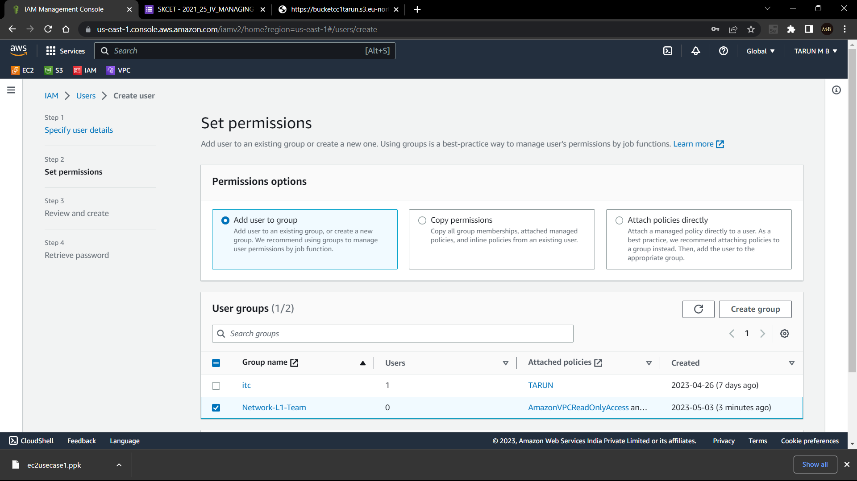

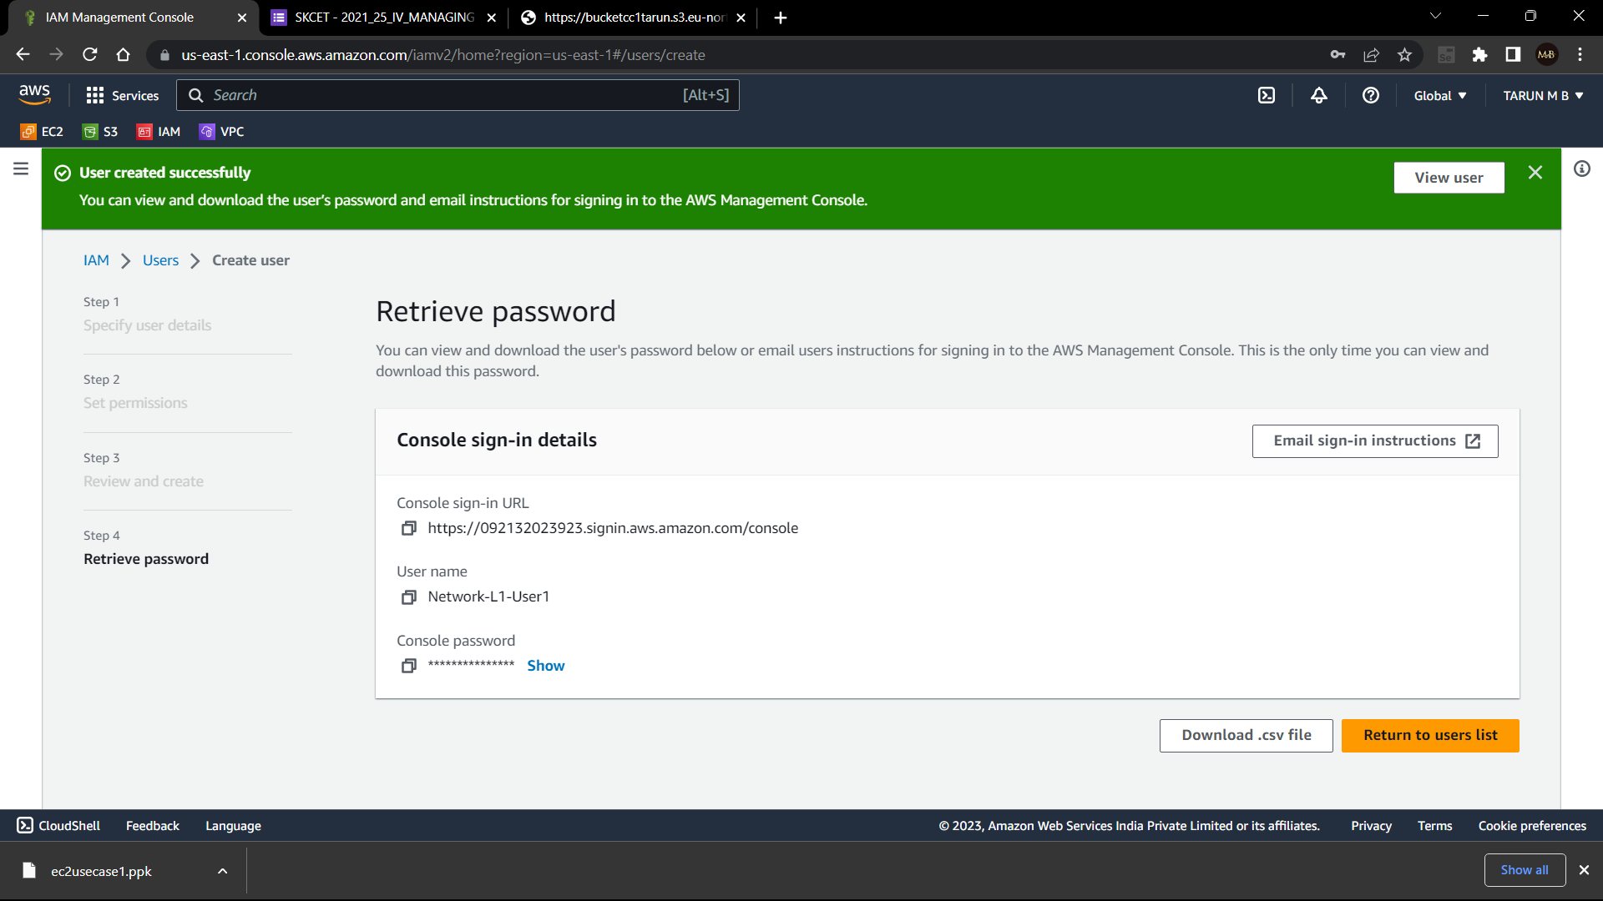

1. Attach “ AmazonVPCReadOnlyAccess” policy.
2. Attach “ AWSNetworkManagerReadOnlyAccess” policy.

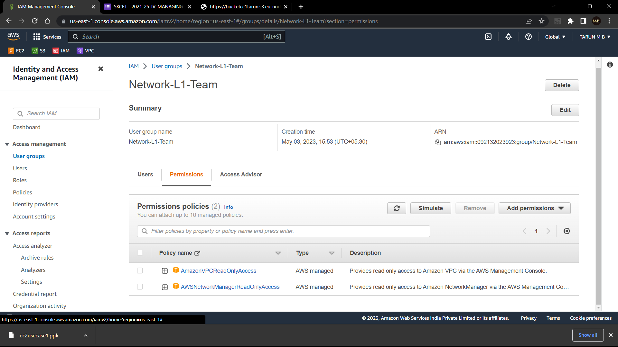

Q3. Create the s3 bucket:

1. Create the new s3 bucket in region Stockholm:

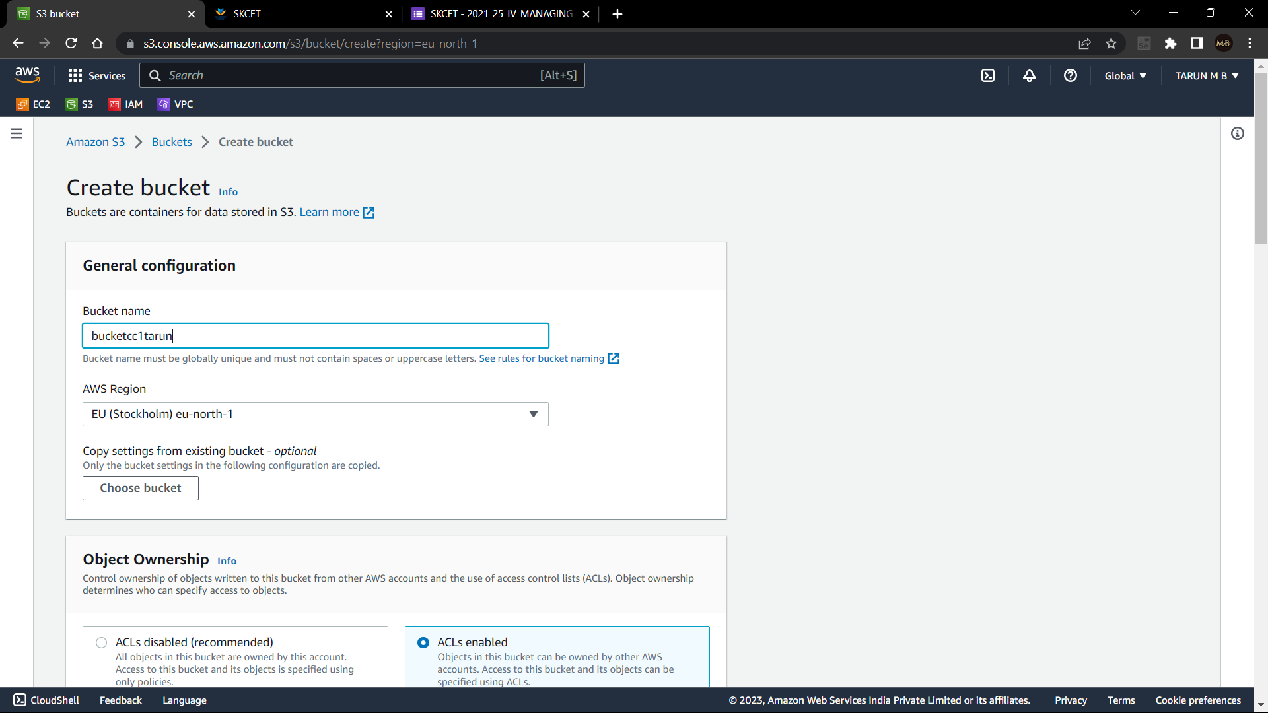

1. Make the bucket accessible to everyone:

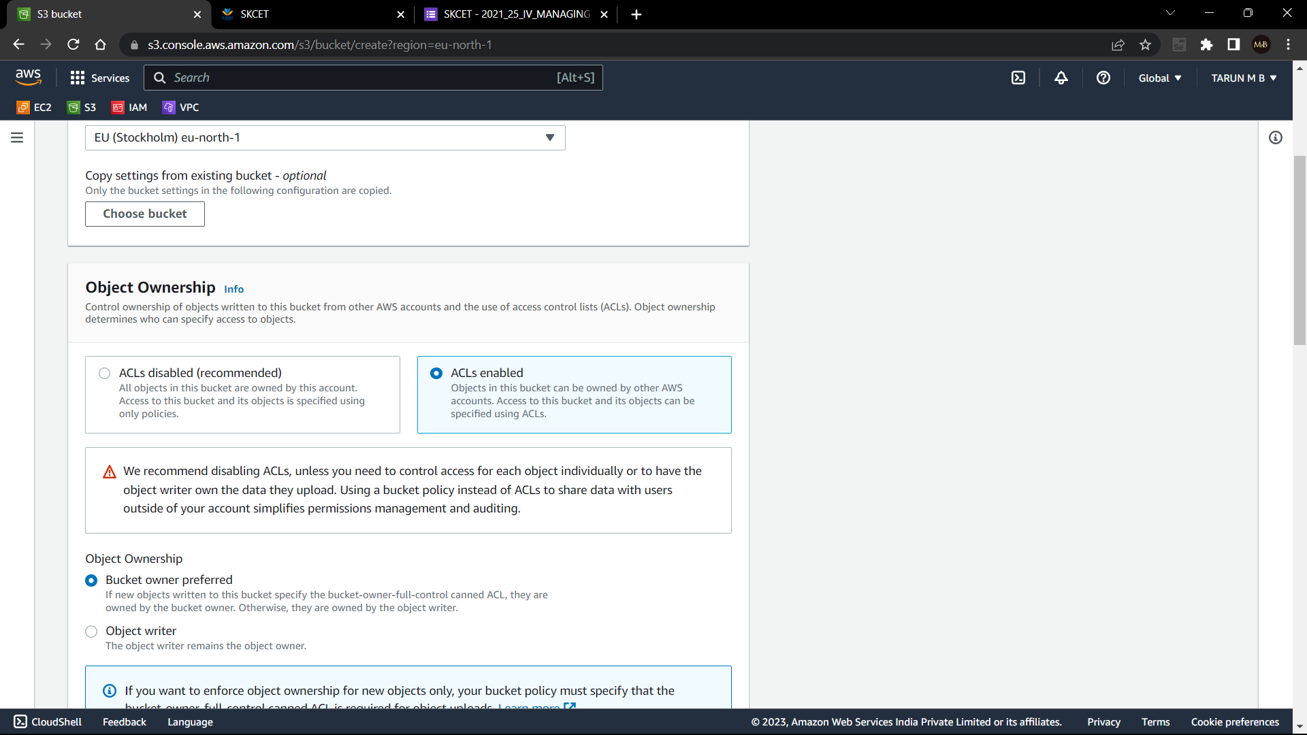

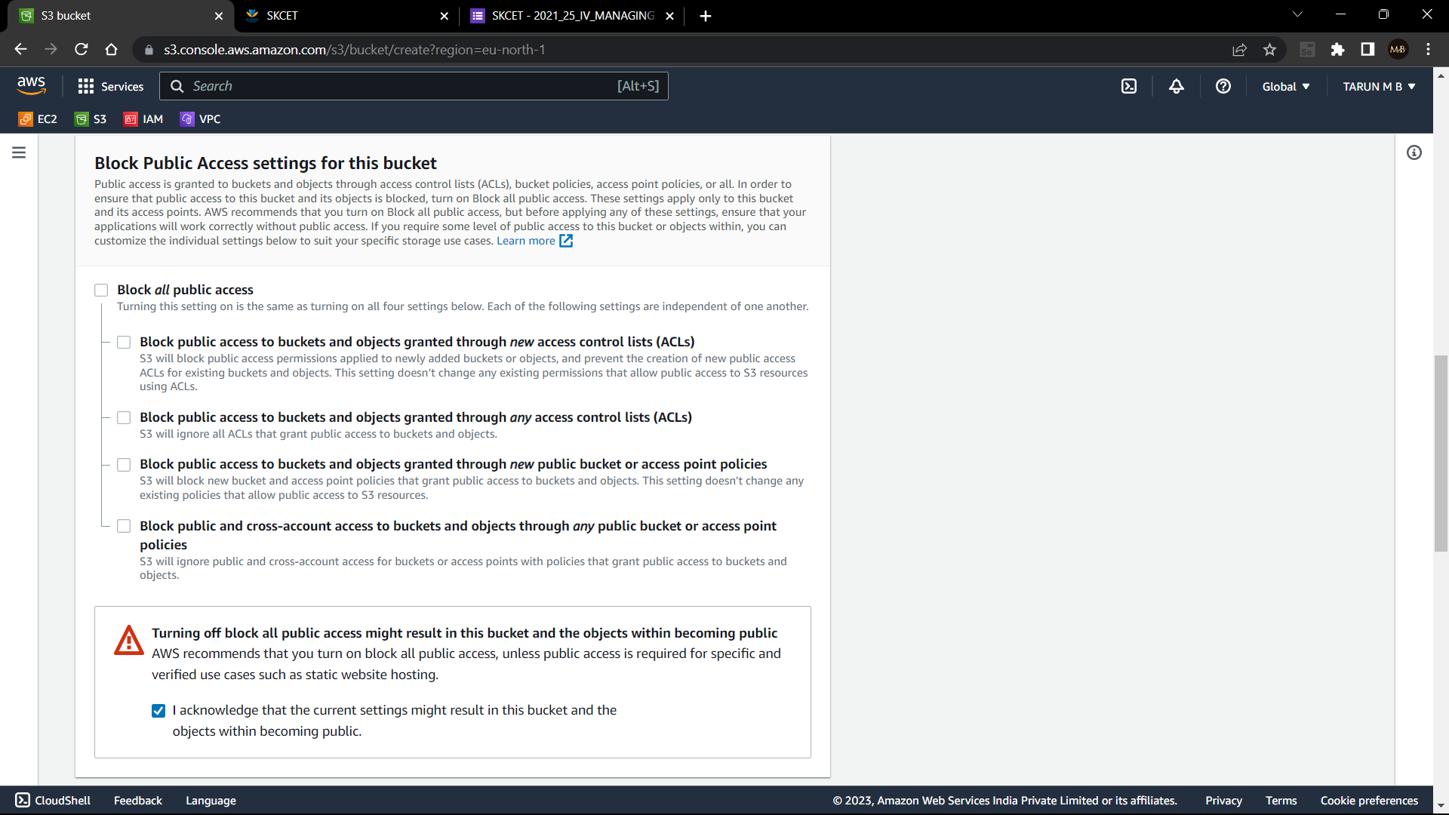

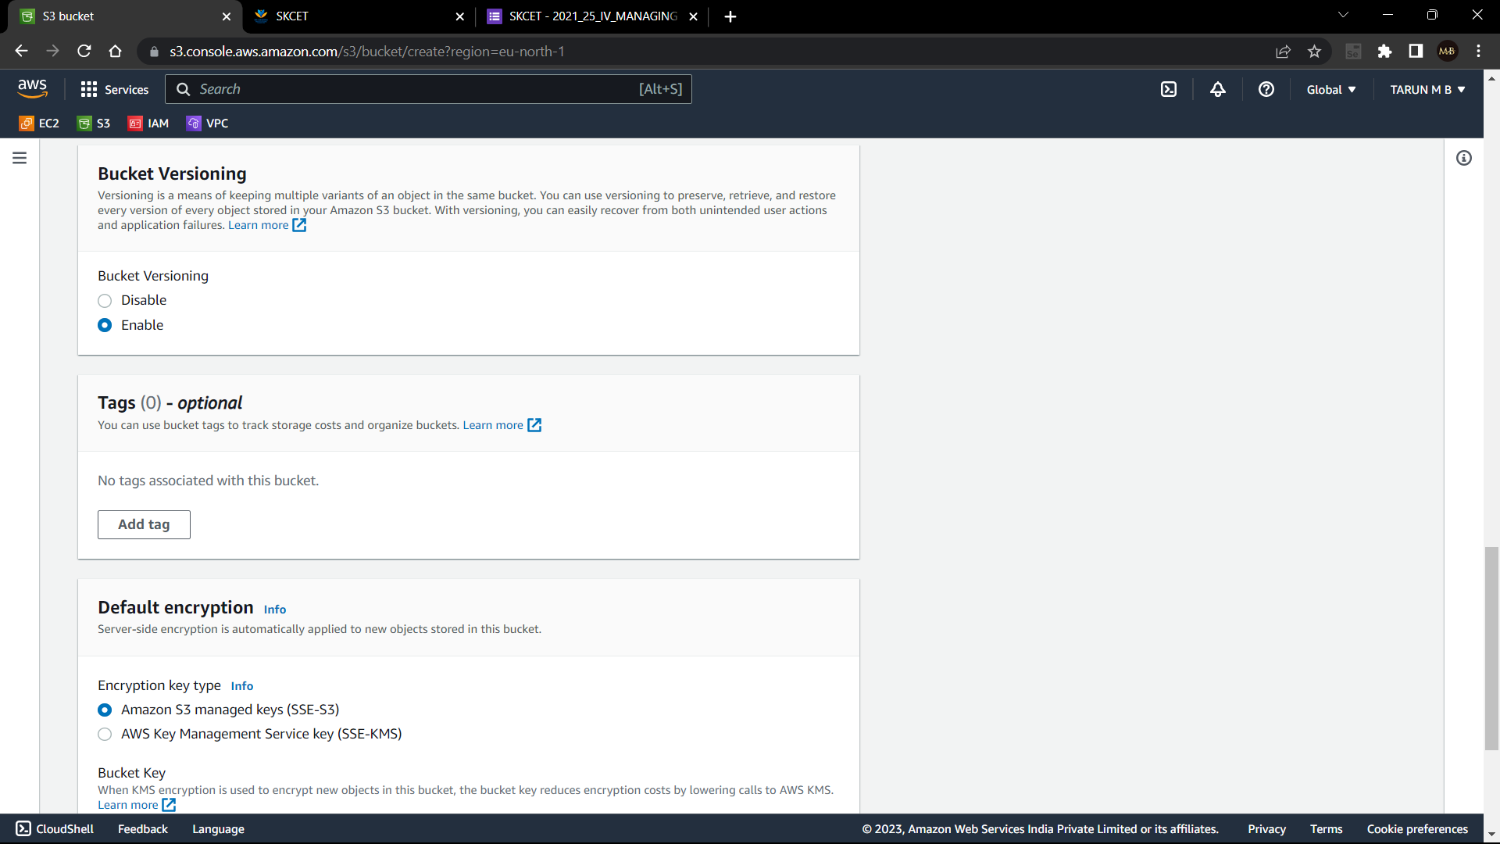

BUCKET CREATED:

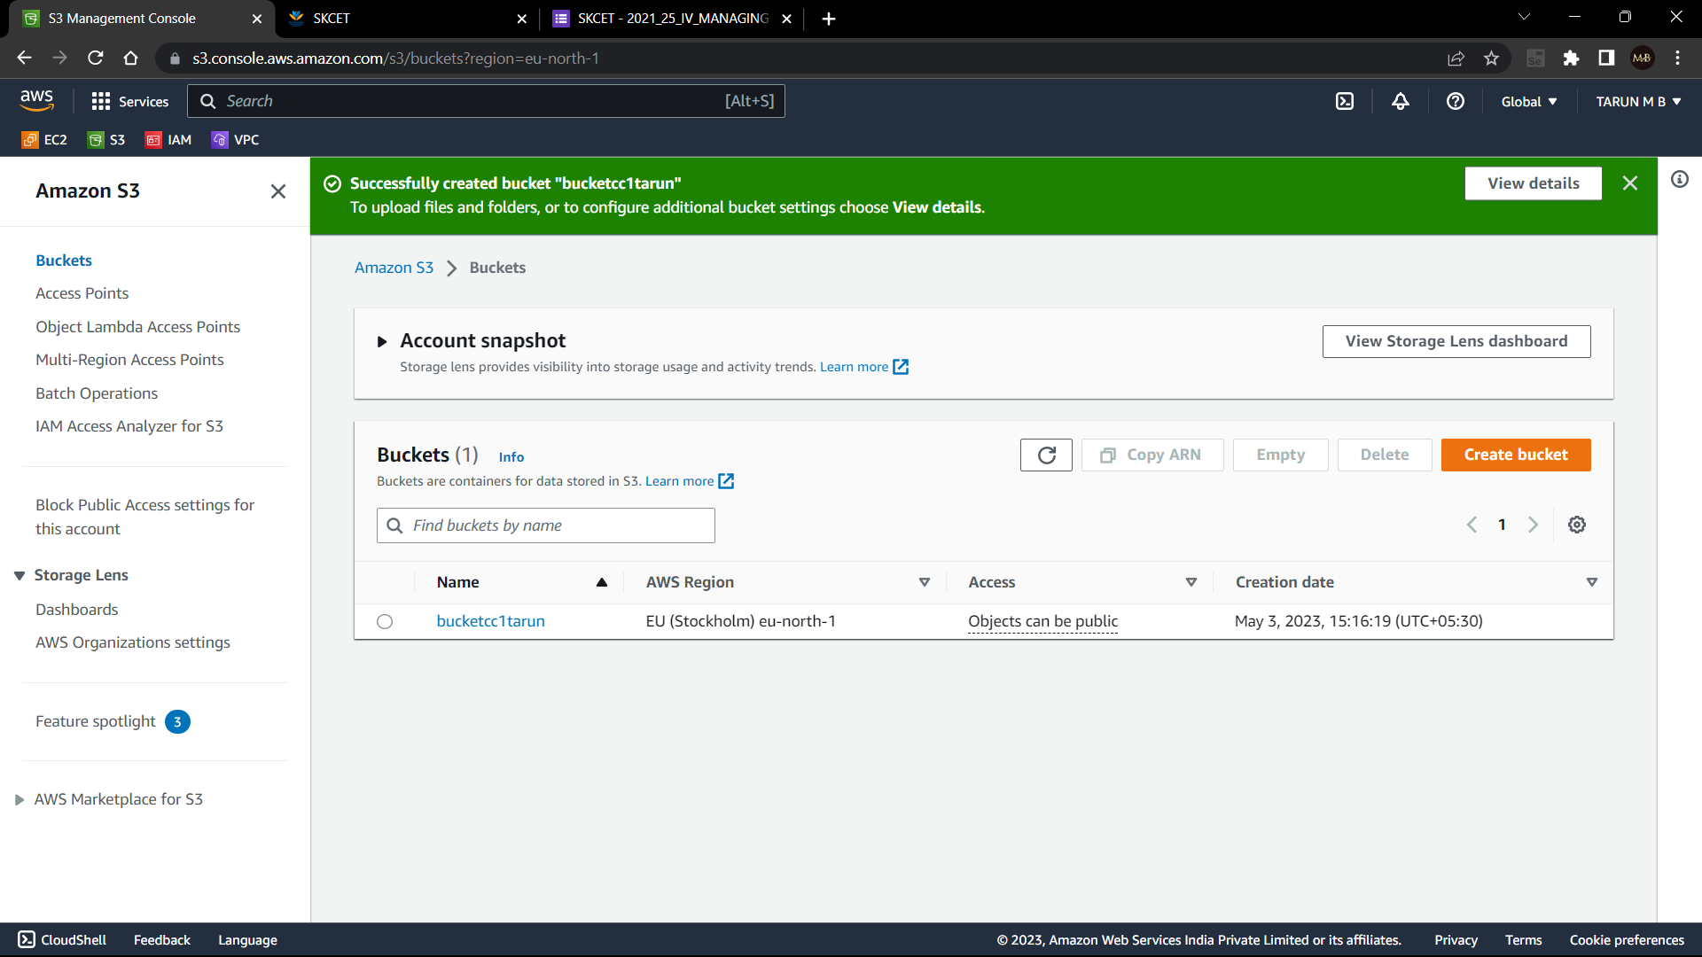

1. Upload the text file in name “accounts.txt”:

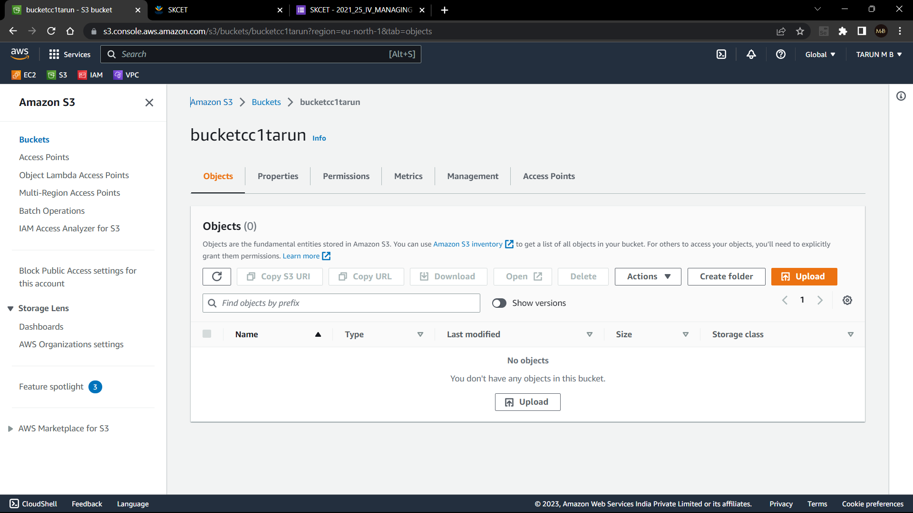

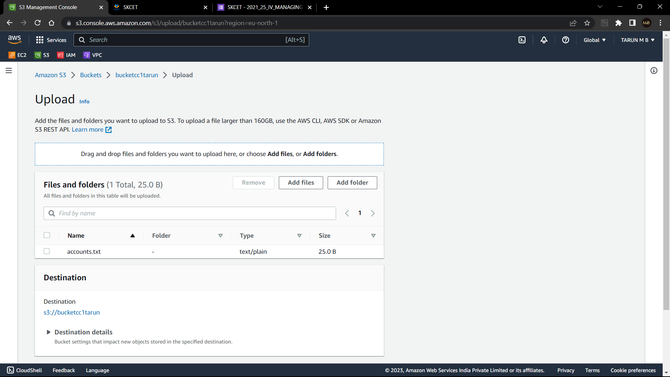

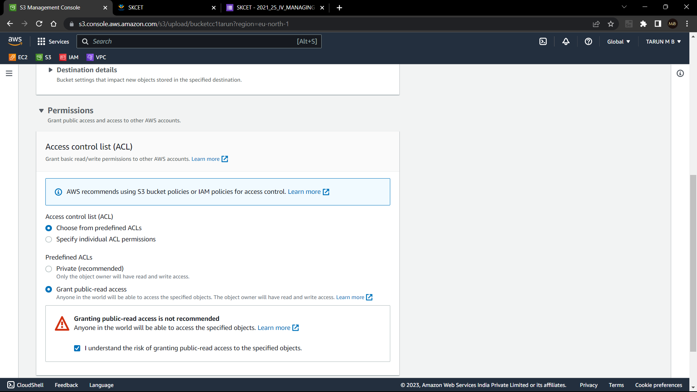

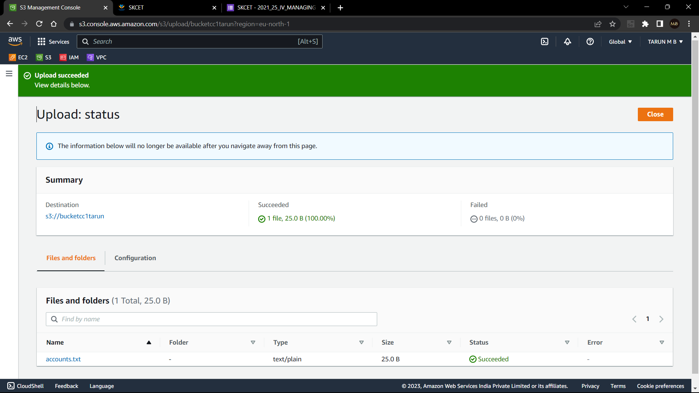

1. Make the object accounts.txt file accessible to everyone

